React js

**React installation**

**Pre requests:** 1 visual studio 2 node.js/ npm

**Step1: How to create react js folder and how to start react js application**

Go to Terminal 🡪 new Terminal 🡪npx create-react-app my-app 🡪cd my-app (it will add **my app folder**) 🡪npm start (it start the application OR it run the project)

my app(folder name)

**Step2:**

Public folder contains images (to open images / enter imageName.extention 🡪http://localhost:3000/logo512.png)

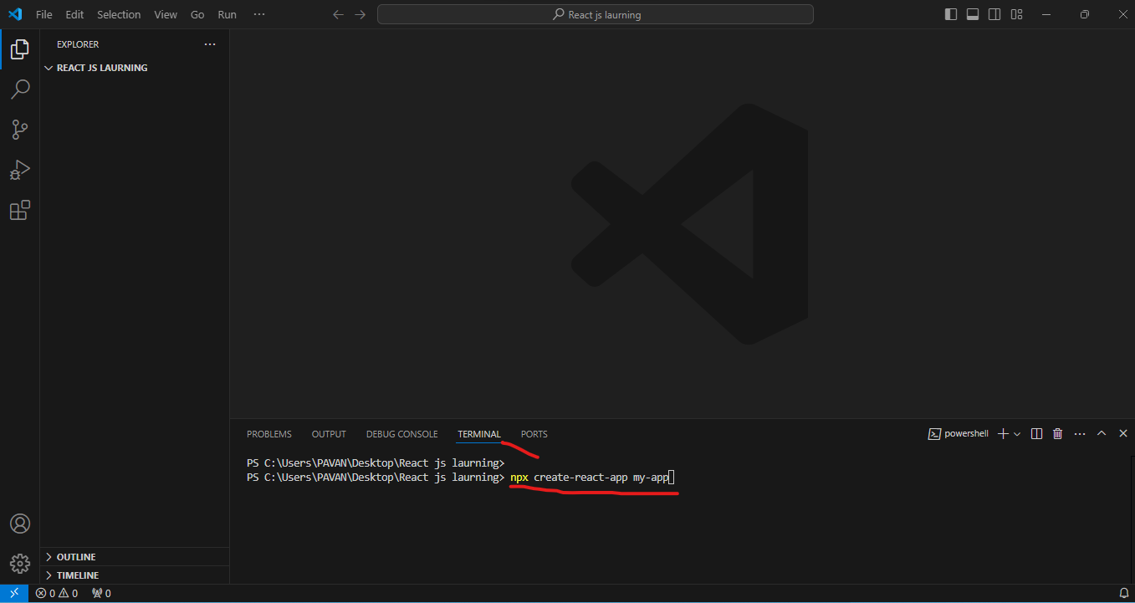

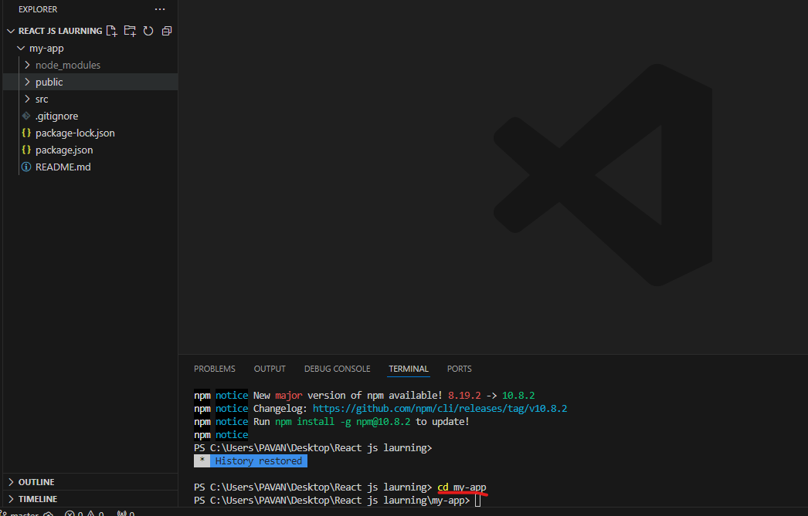

**Git ignore** -->it ignore unnecessary files

README.md: it contains comments like how to start project and how to run project

1. What are components?
2. Use of components?
3. How to create a components?
4. Types of components?

Components are 2 types

1 function component (it is newer version)

**syntax**: Function App () {}

2 class component

Return (): it is a keyword

Return (): is used in a functional component to specify what the component should display on the screen.

If return () is empty or returns null, the component won't display anything.

**Empty Return Example**

function MyComponent() {

return null; }

Errors:

1. ERROR in ./src/App.js 12:42-47

export 'default' (imported as 'Apple') was not found in './Apple' (module has **no exports**)

webpack compiled with 1 error and 1 warning

**solution:**  add export default Apple //Apple is component name

why its throwing error

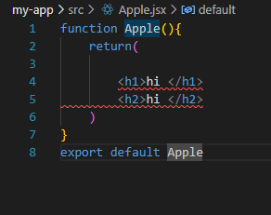

For signal tag/ element it is not throwing an error

